JAVA (PUBLIC PRIVATE PROTECTED)

1) //to demonstrate method overriding adn inheritance

class Animal {

//defined ClassNotFoundException

public void eat(){

System.out.println("eat in parent class");

}

}

//dening parent class

class Dog extends Animal{

public void eat(){

System.out.println("EAT is Subclass");

}

public void Bark(){

System.out.println("Barking");

}

}

public class Main{

public static void main(String[] args){

Animal a=new Animal();

a.eat();

Dog d=new Dog();

d.eat();

Animal c=new Dog();

c.eat();

}

}

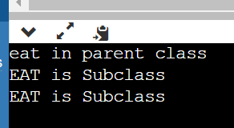

2) public class LinearSearchExample{

public static int LinearSearch(int[]arr,int key){

for(int i=0; i<arr.length; i++){

if(arr[i]==key){

return i;

}

}

return-1;

}

public static void main(String[] args){

int[]a1= {10,20,30,50,70,90};

int key=50;

System.out.println(key+"is found at index:"+LinearSearch(a1,key));

}

}

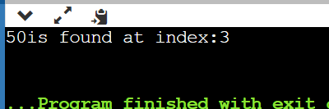

3) import java.util.Scanner;

class TwoDim1{

public static void main(String[] args){

int [][]a= new int [4][3];

Scanner sc=new Scanner(System.in);

for(int i=0; i<4; i++){

for(int j=0; j<3; j++){

a[i][j]=sc.nextInt();

}

}

System.out.println("teo dimensional array elements are:");

for(int i=0; i<4; i++){

for(int j=0; j<3; j++){

System.out.println(a[i][j]);

}

}

}

}

4) public class Board {

public static void main(String[] args){

int[][] board = new int[3][3];

for(int i=0; i<board.length;i++){

for(int j=0; j<board[i].length;j++){

board[i][j]= i+j;

System.out.println(board[i][j]);

}

}

}

}

